**Week 6**

**TEAM MEETING**

***Cameron,*** *Diogo, Jose, Samuel, Yujui, Lio*

## Notes from meetings throughout the week

| **No.** | **Agenda and Minutes** | **Actions needed** |
| --- | --- | --- |
| 2/8 | Ray Cam and Lio tried to use 1DOF setup, position control didnt work at first, learned that controller.config input_mode and control_mdoe must be the same, and at 3 for it to work. Able to do first crude stiff wall demo using Odrive position control | Lio will start getting ready for arduino coding |
| 2/9 | Meeting with Professors - detailed notes below  The mechanism team demonstrated a new prototype for the cable bot with four cable pulleys and a rotational DOF. Different colored graphs were explored to determine best sizing for the chain links, and consideration for a 5 chain closed model was given. Developments to the gantry prototype were also illustrated with custom plates built to decrease mass and inertia. | Diogo to order a large amount of magnets and low friction materials to test out new interface variations  Sam to ideate prototype V2 of the cable bot |
| 2/11 | Ray, Cam and Lio continued to understand Odrive. Connected arduino to Odrive and did first control of Odrive with arduino  Mechanism team developed new CAD models for the magnets with press fit.    And developed a screen raising mechanism for adaptation to different prototypes | Lio will take the lead on coding, do work over weekend  Jose to develop carriage for the Gantry system  Sam to continue working on cable V2  Diogo to develop Magnet V2 and system of attachment to both Gantry and Cable bot |

## Notes From Meeting with Professors

### 1DOF

#### 1 Dof making good progress, getting motor movement and able to do first primitive stiff wall demo

### Mechanism

**Cable robot**

clearly friction is an issue, but many more things we can try to reduce it

putting magnet in plastic already improves a lot

Perhaps use more smaller magnets rather than 1 big one, because field may change more proportional to same distance

Can answer a lot questions with prototype

Have spring thing in tension with motor?

potential problems with cable drive

Rotational constraint may be a difficulty

Design would also require more motors-6

Figure 1: Improvements for V2 of Cable bot, with a focus on the carriage 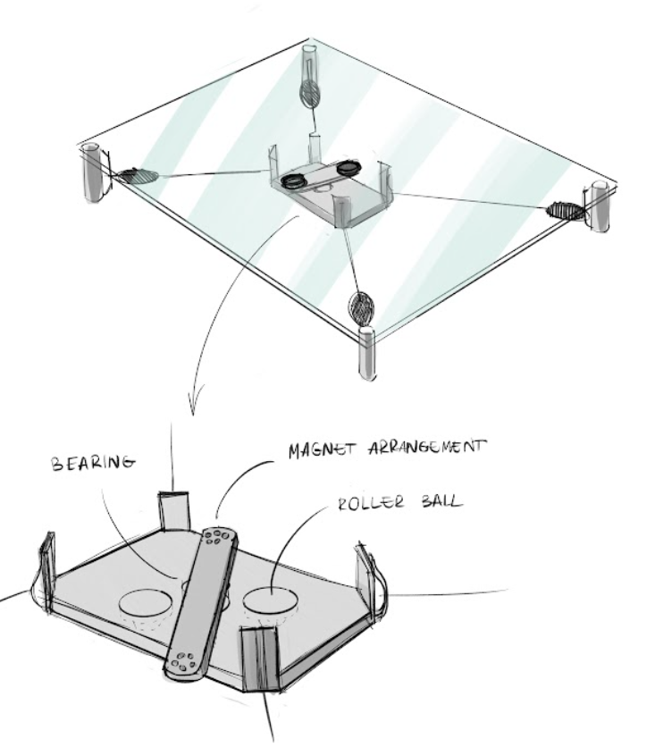

**Arms**

quite large forces in cables

Sam made charts to show singularities and condition number based on geometry

condition numbers get better as arms get longer and farther away

May be a way to optimize for best place to put screen in space

Mounting point relative to screen is important

Radius from the center is probably most critical

Professors say check out the pantograph tho-may be able to modify Sam’s program.

Either style, 2r or closed chain could be done with similar drives, or independent vs 2 in one

5 bar == less swung mass?

can do 2r with motors at the base

advantage of 5 bar == less overall protrusion??

arm has spring pushing it up against screen? Smth like the wand team

#### 

#### How can we measure the friction? Will we be not able to do impedance?

**Gantry**

Start with Teflon, slick plastics

Try felt, especially on glass really low friction

look for ultra-low friction on glass specifically

Styluses also very low friction

Check out gimbal touch screen pens-> what’s on the end??

HDPE

Delrin

Could try balls, although metal on glass sounds scary ->contact point is small, going bigger is bad too

Could non-rotating plastic balls work?->Some section of a sphere? Teflon spheres could be stuck into holes in 3DP. Probably would have to be press fit

What are plastic BBs made of?

#### 

## POST MEETING

### 1DOF

Can you collect data?

Turn off the derivative - start d at 0 and increase p?

Try pure current control cuz if that’s not working than position control wont work

Habit to set current limit and then holding on to it

#### 

### Mechanism